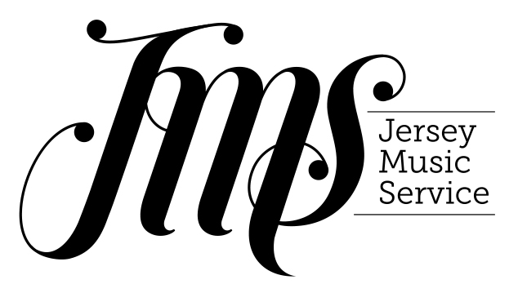
Booking Form
Jersey Music Conference 2017
Thursday 28th September 9am-5pm
Radisson Blu, St Helier

Name of School or Organisation:

Name of Full Day Delegate (9am-5pm):

Role (delete as applicable): Primary Music Coordinator
Secondary Head of Music
Secondary Music Teacher
Instrumental / Vocal Teacher
Other

Please list any dietary requirements:

Name of Head Teacher (attending 9am-10.45am):

Names of Additional Teachers (attending 4pm-5pm):

Payment (delete as applicable):

All the delegates listed on this form are employees of Jersey Schools and therefore entitled to free tickets.

All the delegates listed on this form are non-Jersey Schools employees and therefore agree to pay a charge of £50 per delegate.

If you are not entitled to free places, a member of the Jersey Music Service team will be in contact to arrange payment in advance of the event.

Please email this form to jms@music.sch.je
by Friday 15th September 2017

